Prototype Documentation

Describe how the prototype was proficiently used to evaluate broad concept ideas or different solutions options.

- In the prototype, we explored the broad concepts of mounting apparatuses to the solar panel and rotational motion of the wiper
- For rotational motion, we chose to have our wiper operate 180 degrees, from the center of the panel’s long edge, so that it can clean the entire panel.
- For the mounting apparatus, we needed to show how we intended to hold and support the wiper on the panel, implementing a device that allows for the wiper to move

Describe how the prototype was proficiently used to understand form and physical relationships between elements of the concept solution.

- Foam was put onto the wiper to show a softer brushing material so as to not scratch the panel and remove debris.
- We realized that our mounting apparatus needed to be at a greater height to the side of the panel instead of just being below the panel. With the extra height of our mounting piece, the wiper was attached to the piece with less egregious effort, allowing for an easier install.

Describe how the concept solution proposal includes improvements found through engagement with one or more important functional features.

- We discovered that the mounting system we will likely have plenty of space to house the electronics as well
- We also decided on the position of the wiper. It would be placed in the center and be a shorter wiper than we originally conceptualized. This means that the wiper will have less mass and use less energy.

Describe how the prototype actively follows through on modelling new and potentially risky concepts.

- The geometry of both the mounting system and the wiper was something that could only be considered with a physical prototype. We needed to create a wiper that could reach the entirety of the panel and also not egregiously interrupt the cleaning process of other panels. We needed to create a mounting system that had a universal compatibility with solar panels. We needed to make sure that it’s not a mounting system that we attached to the roof. Through prototyping, we created a device that fit all these specifications.
Images Here w/ Captions:

Solar panel: Solar panel with wiper:
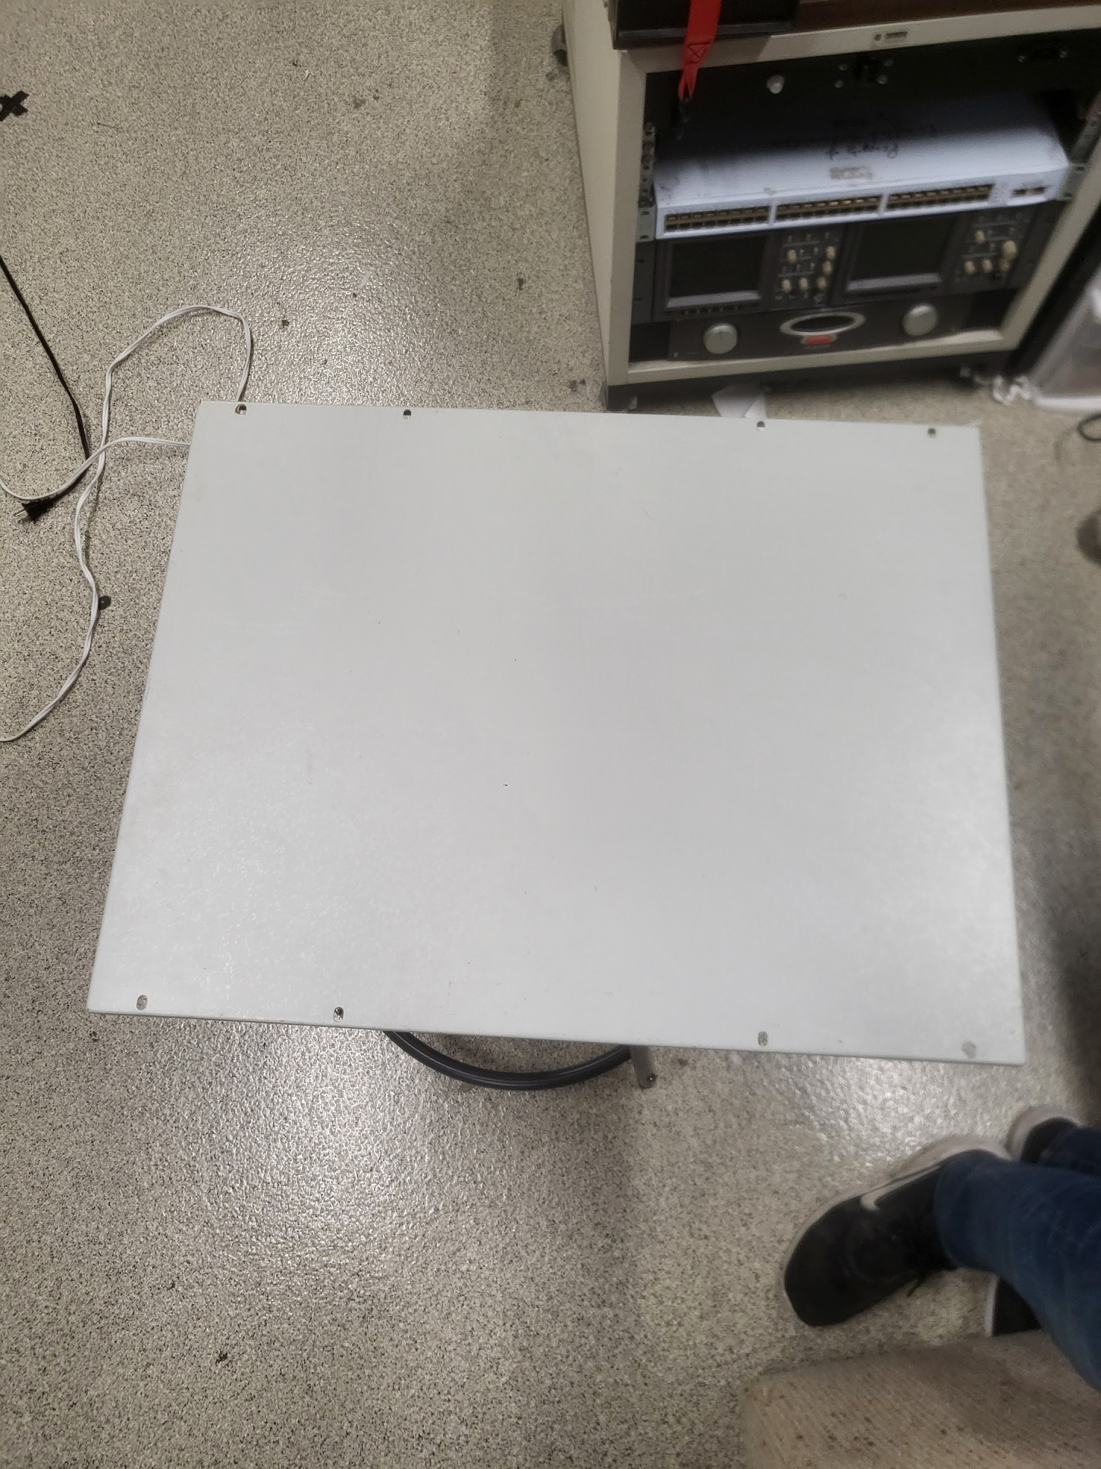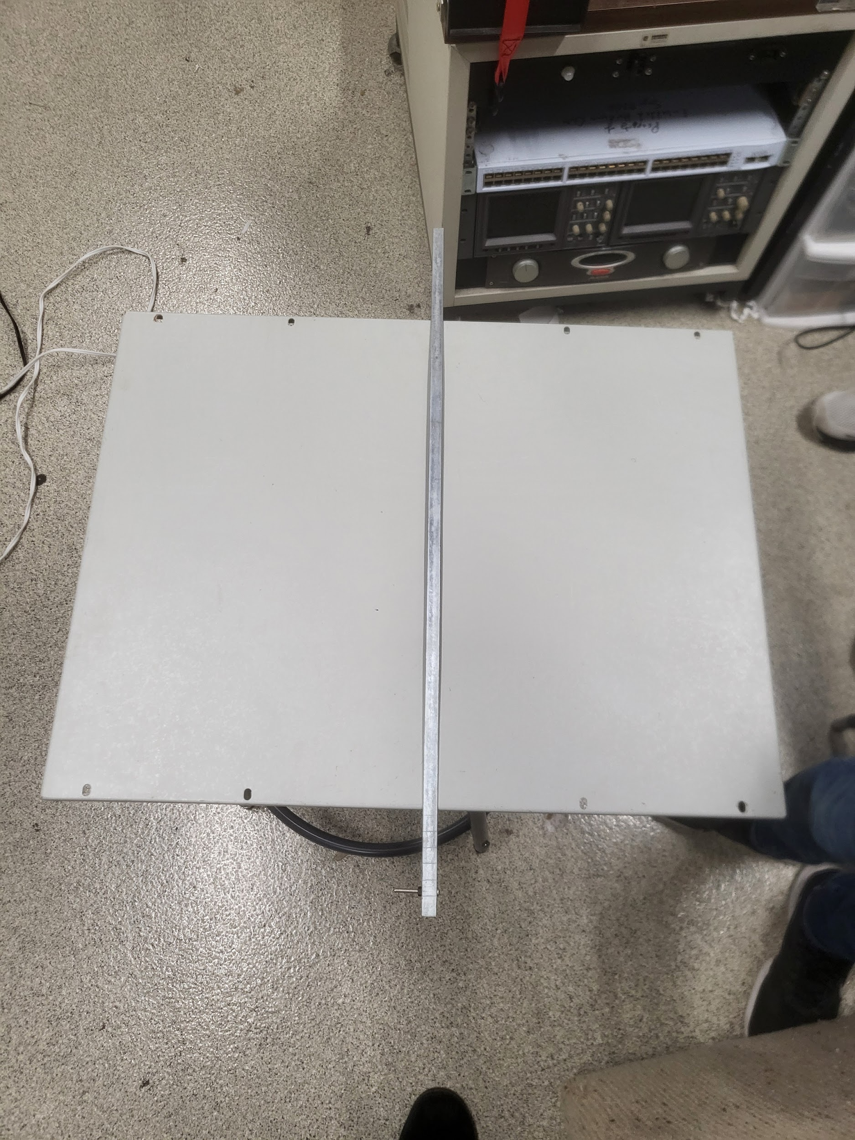

Foam attached to wiper: Mounting apparatus:
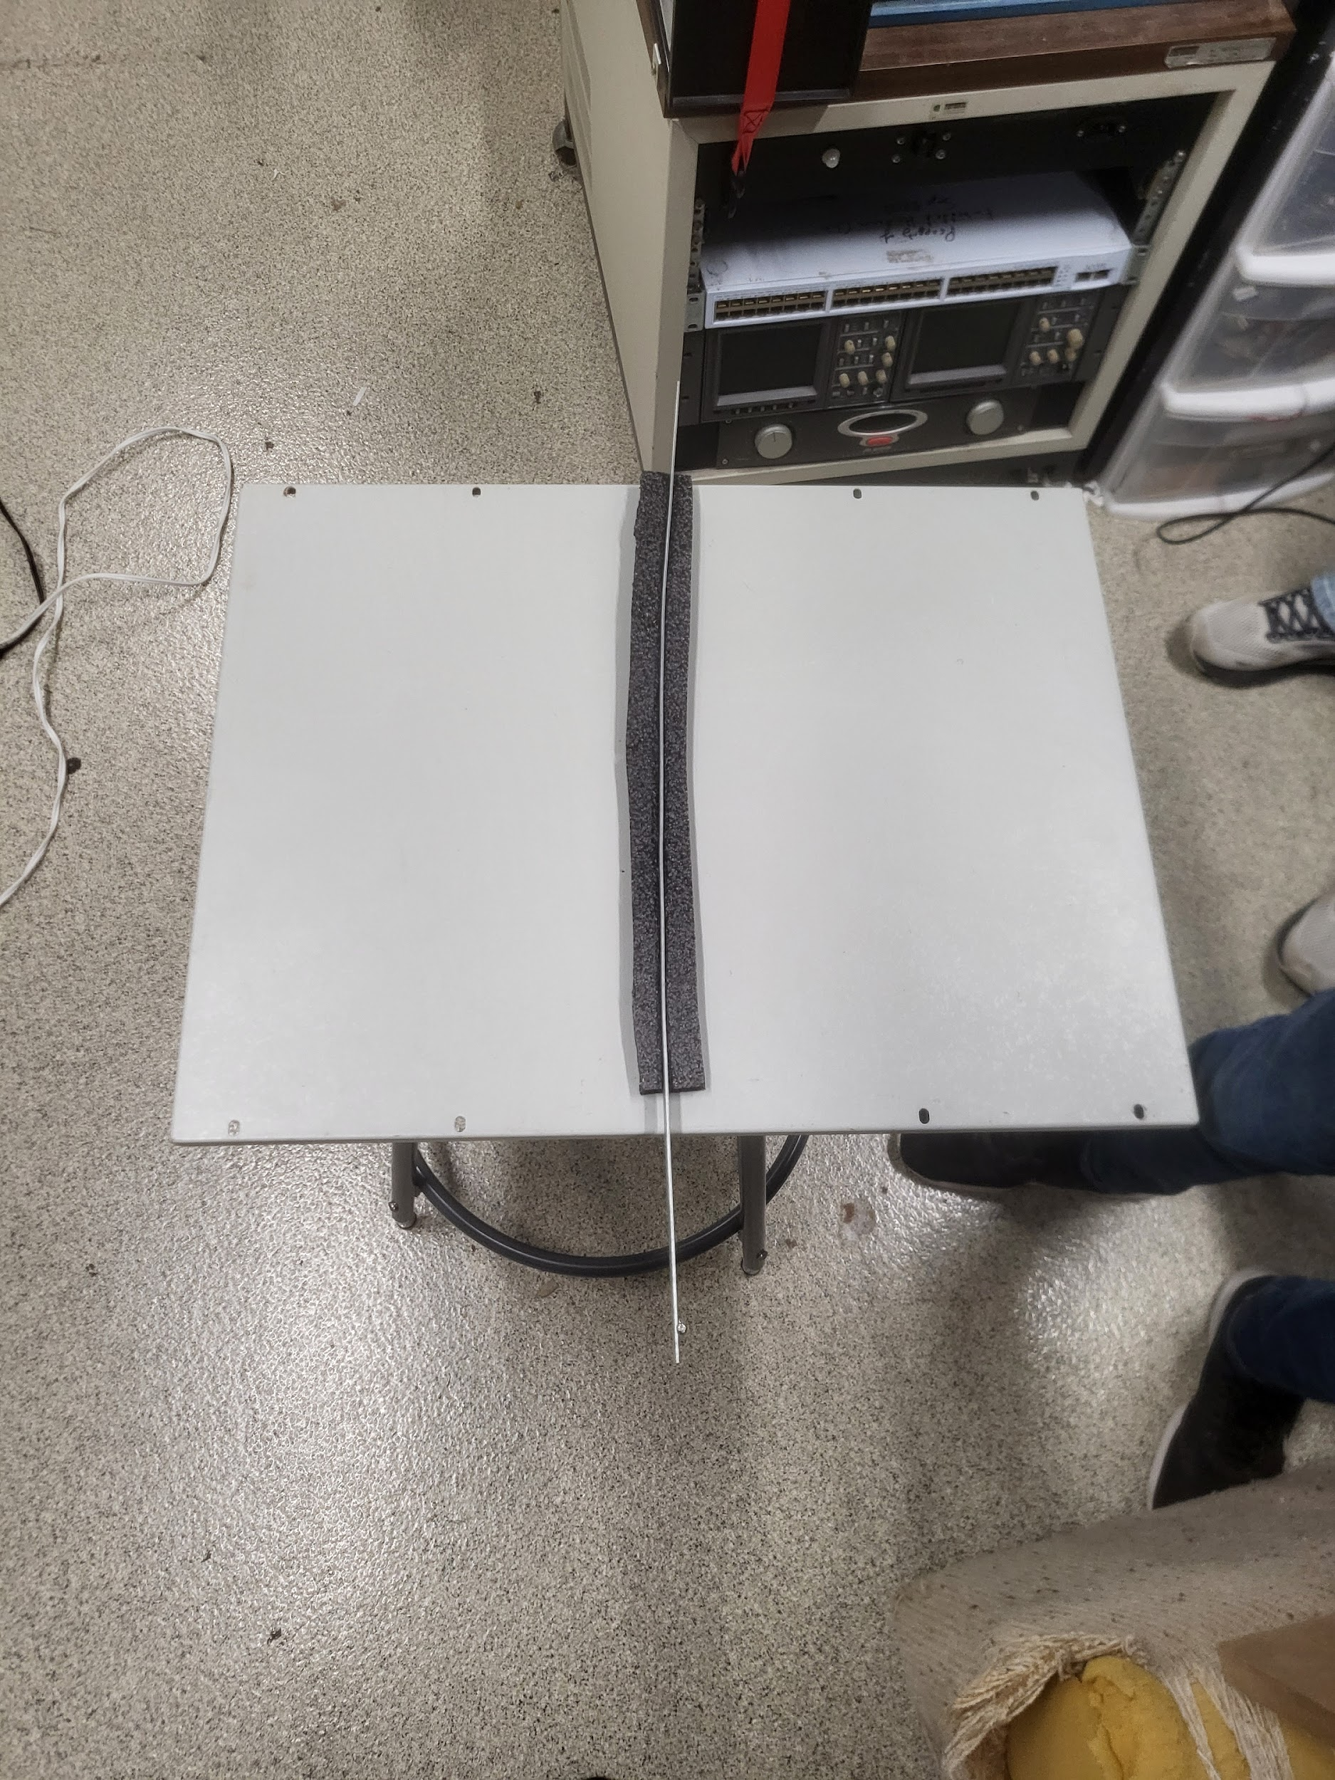 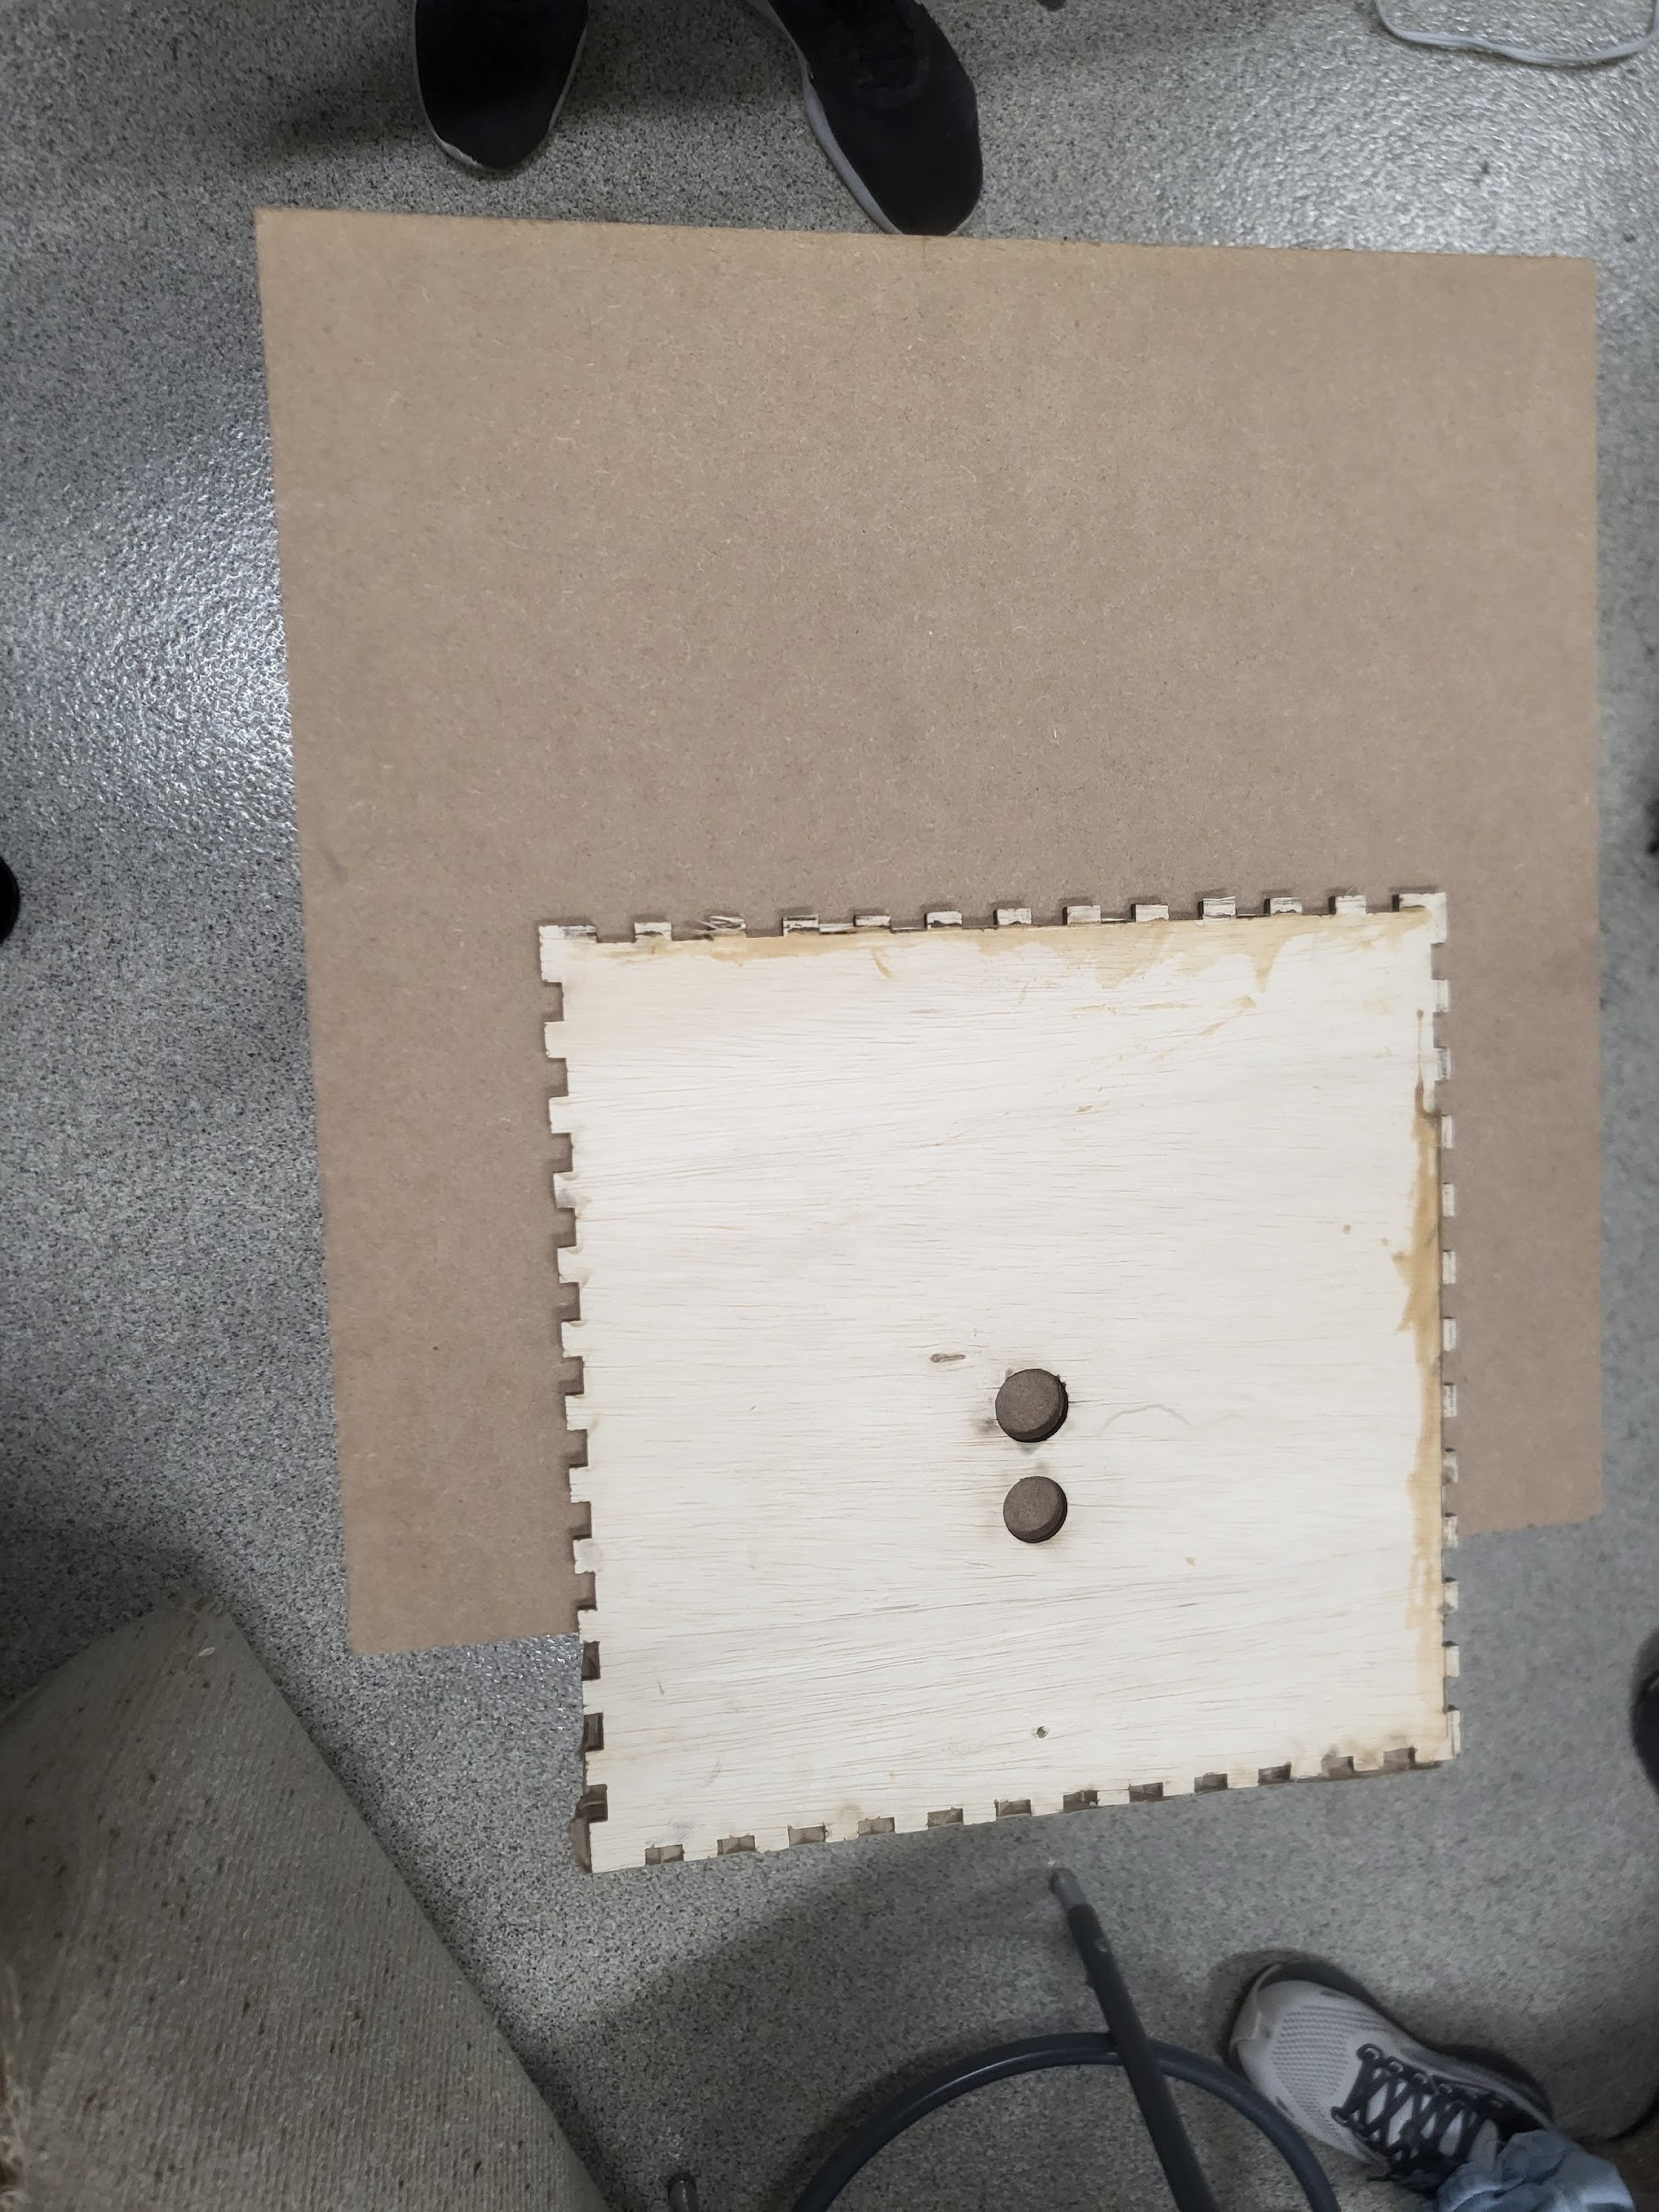

Existing solar panel mounting system Solar panel mounted with it’s mounting systems
with cleaning mounting system added: and cleaning mounting system attached:
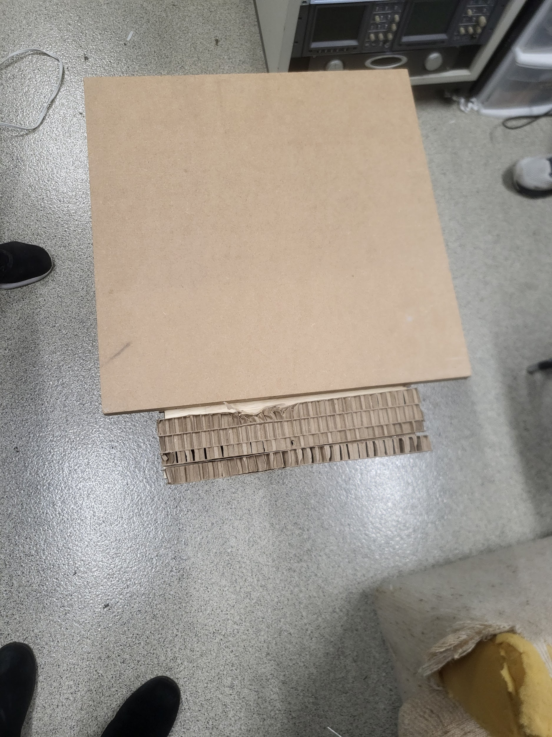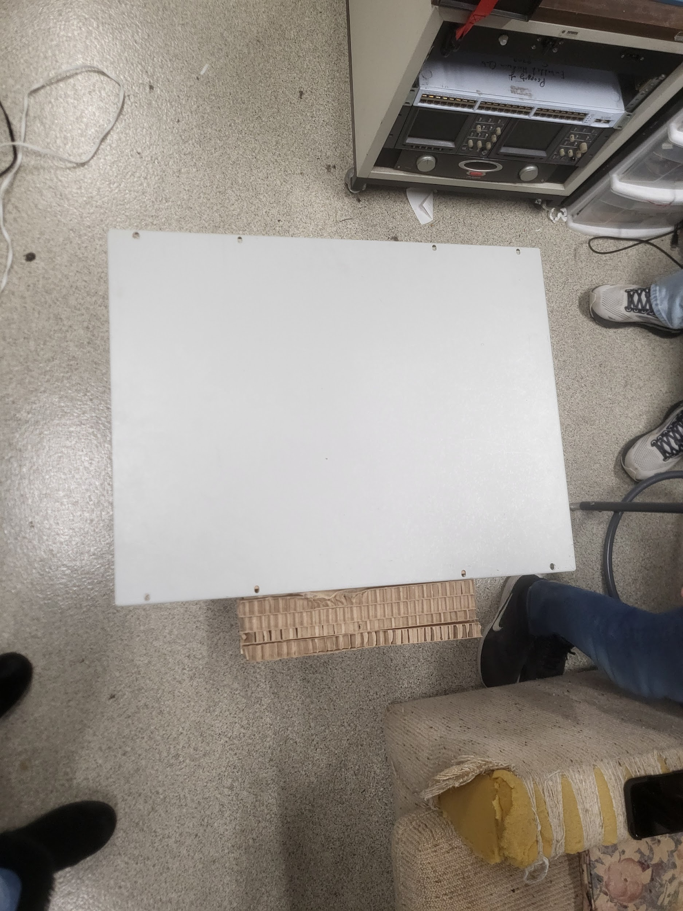

Rotational wiper full lo-fi prototype:
